Running the Server and Local Client

Enclosed in the final build you will find two directories, Server and GUI. Inside these folders you will find their respective executables, “Server.exe” and “GUI.exe”. You can run these independently of eachother, either on the same machine or on different machines. A test-project is included which can be accessed by using the usernames “testuser”, “friend” or “coworker”.

If you run the server on another computer, be sure the change the IP-address in the configuration file “GUI.exe.config”, which is in the same directory as “GUI.exe”. The attribute to be changed can be found contained within the client element. Instead of “localhost”, type in the IP of the computer running “Server.exe”.

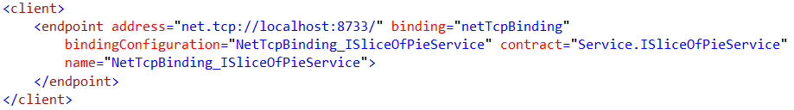

(It might be necessary to have administrative rights when running the server program.)